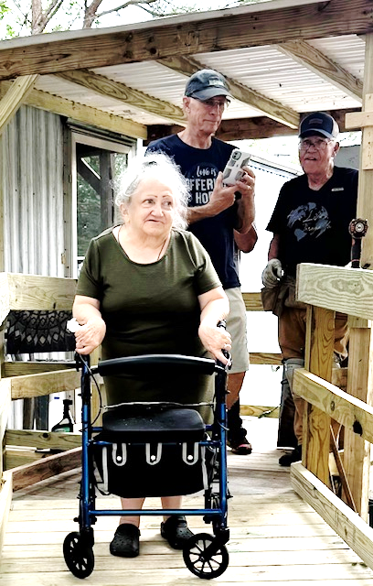
Mary’s Story
Mary, a widow from Porter, found herself in dire need of help. The handicap ramp in front of her home had borne the brunt of many years of weathering and wear. Living alone since her husband's passing, Mary knew it was time to seek assistance to ensure her safety and independence. Additionally, she was desperately in need of a walk-in shower, as having a traditional bathtub made it impossible for her to shower and get in and out safely.
That's when she turned to Habitat for Humanity of Montgomery County (Habitat MCTX) and applied to the Critical Home Repair Program. Her request was met with the generous support of volunteers from The Woodlands Methodist Church, who brought their experience and dedication to the project.
The team built a new handicap-accessible ramp, repaired her awning, and installed a walk-in shower. These improvements have significantly increased Mary's confidence and quality of life. She no longer worries about the ramp's stability or the safety of her bathroom, knowing both are now sturdy and accessible.
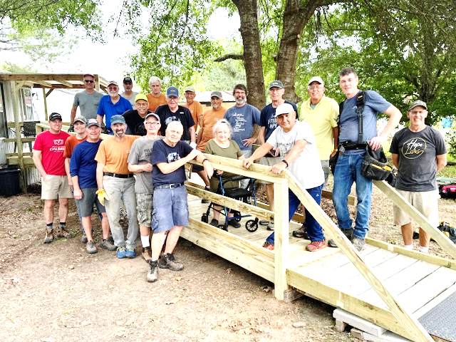
This transformation was made possible through the collaborative efforts of volunteers, community partners, and generous grants funded by LGI Homes, Houston Methodist, Texas Veterans Commission, Momentum Title, Texas State Affordable Housing Corporation, Montgomery County Community Development, Tomball Regional Health Foundation, Montgomery County Community Foundation and Home Depot Foundation.
Together, we were able to repair a much-needed home and provide Mary with a safer living environment. This story is a testament to the power of community support and the positive impact we can achieve when we come together to help those in need.

